GitOps Pipeline — Phase 1: EC2 + kind + ArgoCD + GitHub

- Run a kind Kubernetes cluster on an EC2 instance
- Install ArgoCD inside kind and access its UI from your laptop's browser
- Connect ArgoCD to a public GitHub repo that holds Kubernetes manifests
- Deploy a sample Nginx app via GitOps and open the Nginx welcome page from your laptop

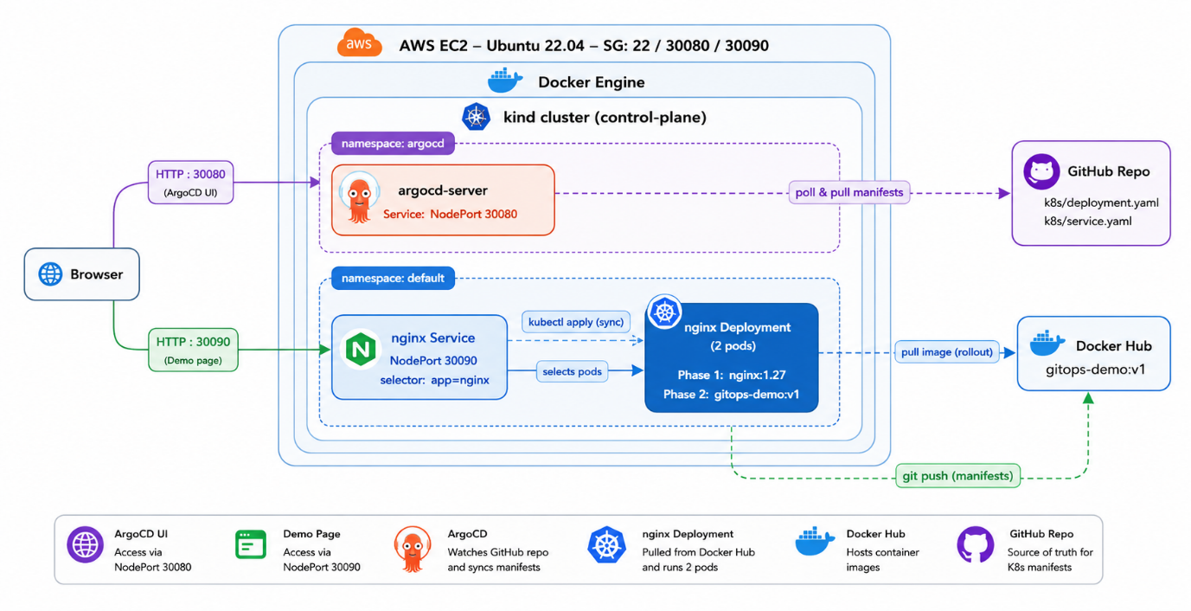

Prerequisites
- AWS account with permission to launch EC2 instances
- A key pair (.pem file) for SSH
- A public GitHub repo (we'll add manifests to it)
- Your laptop's public IP (for security-group rules)
Step 1 — Launch the EC2 Instance
Field | Value
AMI | Ubuntu Server 22.04 LTS (64-bit x86)
Instance type | t3.medium (2 vCPU, 4 GB RAM) — minimum
Storage | 20 GB gp3
Key pair | your existing .pem
Security group | see below
Security Group inbound rules
Type | Protocol | Port | Source | Purpose
SSH | TCP | 22 | My IP | SSH access
Custom TCP | TCP | 30080 | My IP | ArgoCD UI
Custom TCP | TCP | 30090 | My IP | Nginx app
Restrict source to My IP for safety. Open to 0.0.0.0/0 only for short demos.
After launch, note the Public IPv4 address — we'll call it EC2_PUBLIC_IP.
SSH in
chmod 400 my-key.pem
ssh -i my-key.pem ubuntu@EC2_PUBLIC_IP
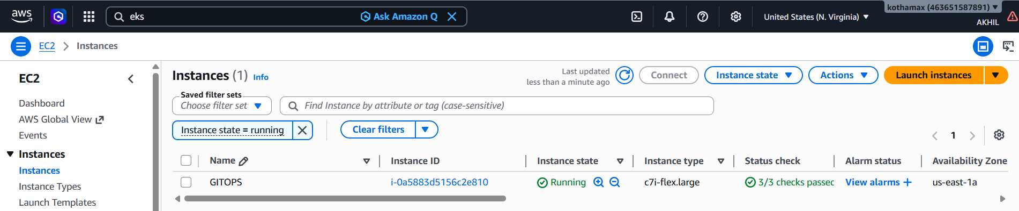
Step 2 — Install Tools on EC2
Run these on the EC2 instance.
2.1 Update + base packages
sudo apt-get update -y
sudo apt-get install -y curl unzip apt-transport-https ca-certificates gnupg lsb-release
2.2 Docker (kind needs it)
curl -fsSL https://get.docker.com | sudo sh
sudo usermod -aG docker ubuntu
newgrp docker # apply group without re-login
docker version
2.3 kubectl
curl -LO "https://dl.k8s.io/release/$(curl -L -s https://dl.k8s.io/release/stable.txt)/bin/linux/amd64/kubectl"
sudo install -o root -g root -m 0755 kubectl /usr/local/bin/kubectl
kubectl version --client
2.4 AWS CLI v2
curl "https://awscli.amazonaws.com/awscli-exe-linux-x86_64.zip" -o awscliv2.zip
unzip -q awscliv2.zip
sudo ./aws/install
aws --version
2.5 Helm
curl https://raw.githubusercontent.com/helm/helm/main/scripts/get-helm-3 | bash
helm version
2.6 kind
curl -Lo kind https://kind.sigs.k8s.io/dl/v0.23.0/kind-linux-amd64
chmod +x kind
sudo mv kind /usr/local/bin/kind
kind version

Step 3 — Create the kind Cluster (with port mappings)
The trick to expose services externally on kind is extraPortMappings. We'll forward:
- EC2 host 30080 → kind node 30080 (ArgoCD UI)
- EC2 host 30090 → kind node 30090 (Nginx)
Create kind-config.yaml on the EC2 instance:
kind: Cluster
apiVersion: kind.x-k8s.io/v1alpha4
name: gitops
nodes:
- role: control-plane
extraPortMappings:
- containerPort: 30080
hostPort: 30080
listenAddress: "0.0.0.0"
protocol: TCP
- containerPort: 30090
hostPort: 30090
listenAddress: "0.0.0.0"
protocol: TCP
Create the cluster:
kind create cluster --config kind-config.yaml
kubectl cluster-info --context kind-gitops
kubectl get nodes
You should see one control-plane node in Ready state.

Step 4 — Install ArgoCD inside kind
4.1 Apply the official manifest
kubectl create namespace argocd
kubectl apply -n argocd -f https://raw.githubusercontent.com/argoproj/argo-cd/stable/manifests/install.yaml
Wait for pods to come up:
kubectl get pods -n argocd -w
Press Ctrl+C once all pods are Running.
4.2 Expose argocd-server as NodePort 30080
By default argocd-server is a ClusterIP service. Patch it to NodePort 30080:
kubectl -n argocd patch svc argocd-server \
-p '{"spec": {"type": "NodePort", "ports": [{"port": 80, "targetPort": 8080, "nodePort": 30080, "name": "http"}, {"port": 443, "targetPort": 8080, "nodePort": 30443, "name": "https"}]}}'
ArgoCD redirects HTTP → HTTPS by default. To make port 30080 plain HTTP (simpler for a demo), disable TLS on the server:
kubectl -n argocd patch deploy argocd-server --type json \
-p '[{"op":"add","path":"/spec/template/spec/containers/0/args/-","value":"--insecure"}]'
kubectl -n argocd rollout status deploy/argocd-server
4.3 Get the initial admin password
kubectl -n argocd get secret argocd-initial-admin-secret \
-o jsonpath="{.data.password}" | base64 -d ; echo
4.4 Open the UI
In your laptop browser:
http://EC2_PUBLIC_IP:30080
Log in with:
- Username: admin
- Password: the value from step 4.3

Step 5 — Prepare the GitHub Repo
In your public GitHub repo, create a folder k8s/ with two files.
k8s/deployment.yaml
apiVersion: apps/v1
kind: Deployment
metadata:
name: nginx
labels:
app: nginx
spec:
replicas: 2
selector:
matchLabels:
app: nginx
template:
metadata:
labels:
app: nginx
spec:
containers:
- name: nginx
image: nginx:1.27
ports:
- containerPort: 80
k8s/service.yaml
apiVersion: v1
kind: Service
metadata:
name: nginx
spec:
type: NodePort
selector:
app: nginx
ports:
- port: 80
targetPort: 80
nodePort: 30090
protocol: TCP
Commit and push. Note your repo URL, e.g. https://github.com/<you>/<repo>.git.

Step 6 — Create the ArgoCD Application
An ArgoCD Application is the object that connects three things: a Git repo + folder (the source of truth), a target namespace in your cluster (where to deploy), and a sync policy (how often / how aggressively to reconcile). Without it, ArgoCD does nothing — it only manages what you explicitly point it at.
You have two equivalent ways to create it:
- Option A (recommended for first-timers): create it through the ArgoCD UI — visual, less intimidating
- Option B (optional, GitOps-purist): apply a YAML manifest with kubectl
Both produce the exact same object in the cluster. Pick one.

Option A — Create via the ArgoCD UI
- Open the ArgoCD UI: http://EC2_PUBLIC_IP:30080 and log in as admin.
- Click "+ NEW APP" (top-left).
- Fill in the form:
GENERAL
Field | Value
Application Name | nginx-app
Project Name | default
Sync Policy | Automatic
☑ Prune Resources | checked
☑ Self Heal | checked
Sync Options → ☑ Auto-Create Namespace | checked
SOURCE
Field | Value
Repository URL | https://github.com/<you>/<repo>.git
Revision | main
Path | k8s
DESTINATION
Field | Value
Cluster URL | https://kubernetes.default.svc
Namespace | default
- Click CREATE at the top.
- ArgoCD will immediately fetch the manifests and start syncing. Within ~30 seconds the tile turns green: Synced / Healthy.
Verify from the EC2 shell:
kubectl get applications -n argocd
kubectl get pods,svc
You should see:
- An Application named nginx-app showing Synced / Healthy
- Two nginx pods Running
- A nginx service of type NodePort on port 30090

Option B (optional) — Create via YAML manifest
This is the GitOps-purist way: the Application object itself lives in Git, so even ArgoCD's configuration is version-controlled. Useful when you want reproducibility — e.g., recreating the cluster from scratch with a single kubectl apply.
Create argocd-app.yaml on the EC2 instance:
apiVersion: argoproj.io/v1alpha1 # ArgoCD's API group
kind: Application # The CRD type
metadata:
name: nginx-app # Name shown in ArgoCD UI
namespace: argocd # MUST be argocd (where ArgoCD lives)
spec:
project: default # ArgoCD "project" — default is fine for a POC

source: # WHERE the manifests live
repoURL: https://github.com/<you>/<repo>.git
targetRevision: main # Branch / tag / commit to track
path: k8s # Folder inside the repo to apply

destination: # WHERE to deploy them
server: https://kubernetes.default.svc # "this same cluster"
namespace: default # K8s namespace to deploy into

syncPolicy: # HOW to keep them in sync
automated:
prune: true # Delete K8s resources removed from Git
selfHeal: true # Revert manual kubectl edits back to Git
syncOptions:
- CreateNamespace=true # Auto-create namespace if missing
Apply it:
kubectl apply -f argocd-app.yaml
Watch the sync:
kubectl get applications -n argocd
kubectl get pods,svc
UI vs YAML — they are the same object. If you create the app in the UI, you can later run kubectl get application nginx-app -n argocd -o yaml and you'll see almost exactly the manifest above. The UI is just a form that writes this YAML for you.

Step 7 — Open Nginx in Your Browser
http://EC2_PUBLIC_IP:30090
You should see the "Welcome to nginx!" page. That confirms:
GitHub repo → ArgoCD pulled the manifests → kind applied them → kind port-mapped 30090 → EC2 security group allowed it → your browser rendered it.

Step 8 — Test the GitOps Loop
Edit k8s/deployment.yaml in GitHub: change replicas: 2 to replicas: 3, commit, push.
Within ~3 minutes (default ArgoCD poll interval) — or instantly if you click Refresh in the UI — you'll see a 3rd nginx pod appear:
kubectl get pods -l app=nginx
That is GitOps: the cluster matches the repo, automatically.

Troubleshooting
Symptom | Likely cause | Fix
Browser hangs on :30080 | Security group missing the port | Add inbound rule for 30080
kind create cluster fails: permission denied on docker | User not in docker group | sudo usermod -aG docker ubuntu && newgrp docker
ArgoCD shows ComparisonError: repository not accessible | Repo URL typo or repo private | Verify URL; for private repos add credentials in ArgoCD
Nginx page loads on EC2 (curl localhost:30090) but not from laptop | Firewall / SG | Re-check inbound rule for 30090
argocd-server pod stuck in CrashLoopBackOff after --insecure patch | Patch path wrong | kubectl -n argocd edit deploy argocd-server and ensure --insecure is in args:
t3.medium runs out of memory | Cluster + ArgoCD is heavy | Use t3.large (8 GB)

Cleanup
kind delete cluster --name gitops
# Then terminate the EC2 instance from the AWS console

Phase 2 — Deploy Your Own Container Image via ArgoCD
In Phase 1, ArgoCD pulled the public nginx:1.27 image from Docker Hub. In Phase 2 we replace that with a custom image that we build ourselves from a Dockerfile. Everything else stays the same — same kind cluster, same ArgoCD, same Service on NodePort 30090. Only the image: field in deployment.yaml changes.
What we'll do
- Build a Docker image from the containerisation/ folder (a colorful animated HTML page served by Nginx)
- Push the image to Docker Hub (free, public)
- Update k8s/deployment.yaml in your GitHub repo to point to your new image
- ArgoCD detects the Git change and rolls out the new pods automatically

Step 9 — Files in containerisation/
containerisation/
├── Dockerfile # Builds an Nginx image with our custom index.html
└── index.html # Animated GitOps demo page
Dockerfile (already in this repo):
FROM nginx:alpine
COPY index.html /usr/share/nginx/html/index.html
EXPOSE 80
Why nginx:alpine? It's tiny (~25 MB), and we just need a static-file web server. The COPY line replaces Nginx's default welcome page with our own.
The index.html is a self-contained page (gradient background, floating rocket, animated badges) that renders the message "Deployed on Kind K8s Cluster using ArgoCD". No external assets — works offline.

Step 10 — Build & Push the Image to Docker Hub
You can run these on your laptop or on the EC2 instance — both have Docker.
# 1. Log in to Docker Hub (one-time)
docker login
# enter your Docker Hub username + password / access token

# 2. From the project root, build the image
# Replace <dockerhub-user> with your Docker Hub username
docker build -t <dockerhub-user>/gitops-demo:v1 ./containerisation

# 3. Push it
docker push <dockerhub-user>/gitops-demo:v1
Verify on https://hub.docker.com/ — you should see the gitops-demo repository with tag v1.
Tip on tags: Avoid :latest for GitOps. Use explicit versions like v1, v2, … so ArgoCD has a clear "before vs after" to reconcile.

Step 11 — Update k8s/deployment.yaml in GitHub
Open your GitHub repo (the same one ArgoCD already watches) and edit k8s/deployment.yaml. Change only the image: line:
apiVersion: apps/v1
kind: Deployment
metadata:
name: nginx # ← keep the name (so the Service selector still matches)
labels:
app: nginx # ← keep this label too
spec:
replicas: 2
selector:
matchLabels:
app: nginx
template:
metadata:
labels:
app: nginx # ← Service still selects on this label, no change needed
spec:
containers:
- name: nginx
image: <dockerhub-user>/gitops-demo:v1 # ← THE ONLY CHANGE
ports:
- containerPort: 80
Commit and push.
Why the Service file doesn't need to change: the Service selects pods by the label app: nginx. As long as your new Deployment keeps that label and exposes containerPort: 80, the existing nginx Service on NodePort 30090 automatically routes traffic to your new pods.

Step 12 — Watch ArgoCD Sync
In the ArgoCD UI:
- The nginx-app tile turns yellow (OutOfSync) within ~3 minutes — or click REFRESH for instant detection
- Because we set automated: { prune: true, selfHeal: true }, it auto-syncs and turns green again
- A rolling update happens — old pods terminate, new pods come up with your image
Or from the EC2 shell:
kubectl rollout status deployment/nginx
kubectl get pods -l app=nginx
kubectl describe pod -l app=nginx | grep Image:
The Image: line should now show <dockerhub-user>/gitops-demo:v1.

Step 13 — Open Your Custom Page
Same URL as before:
http://EC2_PUBLIC_IP:30090
Instead of the plain Nginx welcome page, you should now see your animated GitOps demo page.
That confirms the full loop:
Dockerfile → docker build → Docker Hub → edit deployment.yaml in GitHub → ArgoCD syncs → kind rolls out new pods → your browser shows the new page.

Iterating: ship a v2
To prove the GitOps loop end-to-end:
- Edit containerisation/index.html (e.g., change a heading)
- docker build -t <dockerhub-user>/gitops-demo:v2 ./containerisation
- docker push <dockerhub-user>/gitops-demo:v2
- In GitHub, change the image tag from :v1 to :v2, commit, push
- ArgoCD detects the change → rolling update → refresh the browser
You never ran kubectl apply for any of it. That is GitOps.

